***************************************************************************************

03/06/2024 - Monday

***************************************************************************************

**What is Python?**

->Python is a popular programming language.

->Created by Guido van Rossum, and released in 1991.

->simple syntax similar to the English language.

->runs on an interpreter system.

->Python can be treated in a procedural way, an object-oriented way or a functional way.

--------------------------------------------------------------------------------------

=> Can be used :

- on a server to create web applications.

* Python is Case sensitive.

--------------------------------------------------------------------------------------

XAMPP : means->

X->Cross-Platform

A->Apache

M->MariaDB

P->PHP

P->PERL

--------------------------------------------------------------------------------------

1. **Python Indentation**

Indentation refers to the spaces at the beginning of a code line.

Example:

if 5 > 2:

print("Five is greater than two!")

Syntax Error:

if 5 > 2:

print("Five is greater than two!")

--------------------------------------------------------------------------------------

1. **Python Variables**

Example

x = 5

y = "Hello, World!"

--------------------------------------------------------------------------------------

1. **Python Comments**

* comments start with '#' in python.
* There is NO syntax for Multiline Comments in python
* To add a multiline comment you could insert a # for each line.
* But , you can use a multiline string.

***************************************************************************************

05/06/2024 - Wednesday

1. **Compiler vs Interpreter :**

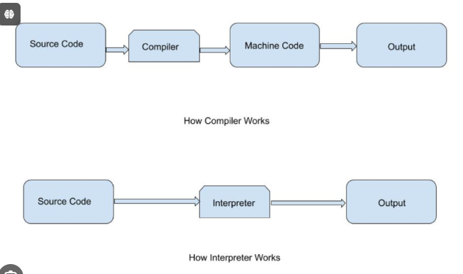

1. **Python interactive Mode :**

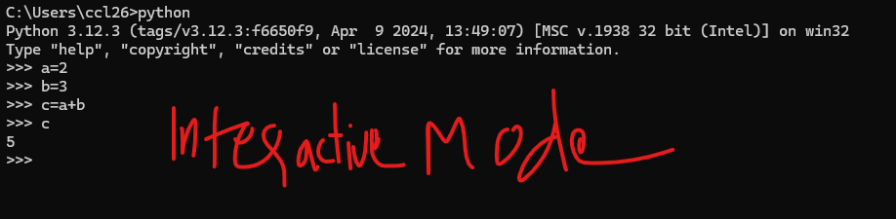

1. **Python Variables :**
   * **Casting :** If you want to specify the data type of a variable, this can be done with casting.

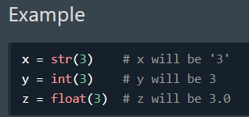

* + **Get the Type :** You can get the data type of a variable with the type() function.

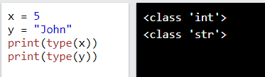

* + **Variable name :**

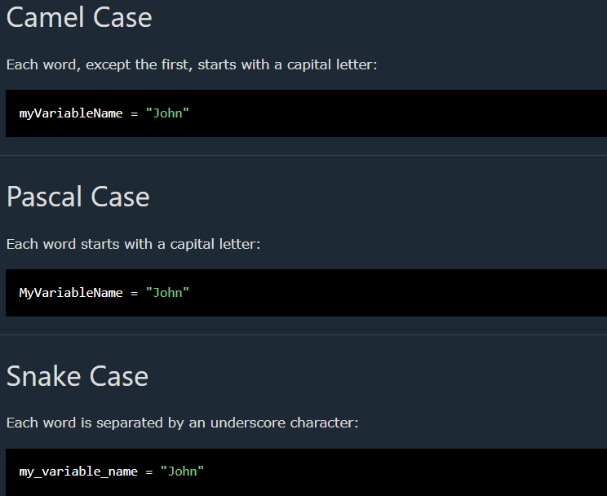

* + **Assign values to Mltiple variables :**

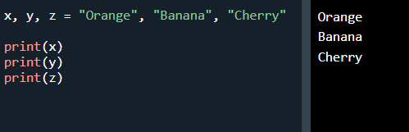

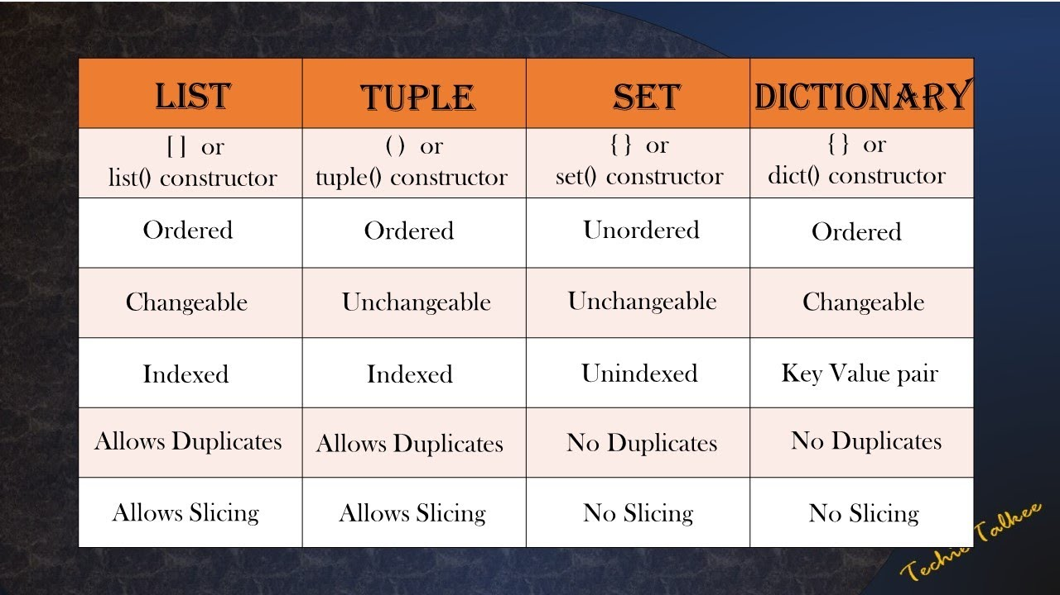

1. **Python List:**

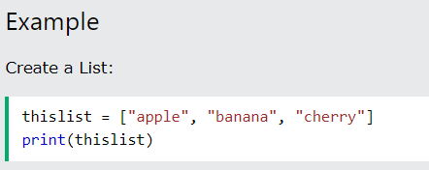

* + Lists are used to **store multiple items in a single variable**.
  + Lists are created using square brackets.
  + **List is :**
    - **Ordered,**
    - **Changeable,**
    - **Allow Duplicates**

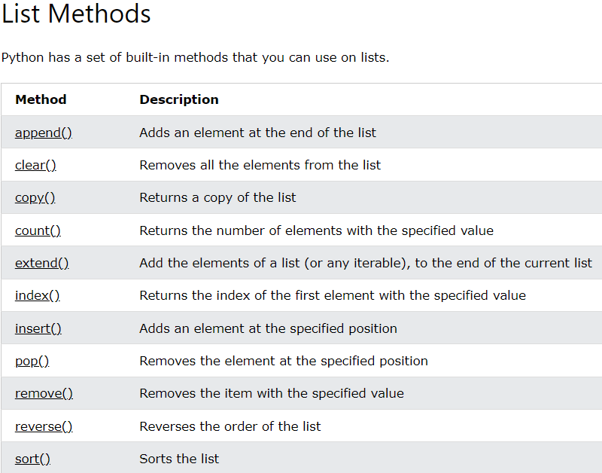

1. **Python Tuples:**
   * 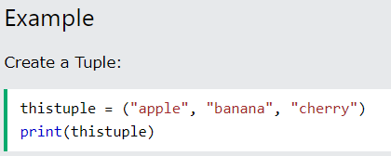
   * Tuples are used **to store multiple items in a single variable**.
   * A tuple is a collection which is:
     + **ordered** .
     + **Unchangeable.**
     + **Allow Duplicates.**
2. **Python Sets:**
   * 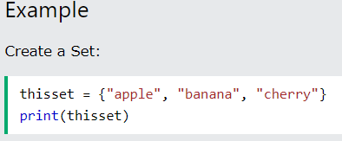
   * Sets are used **to store multiple items in a single variable**.
   * A Sets is a collection which is:
     + **Unordered** .
     + **Unchangeable.**
     + **Duplicates Not Allowed.**
3. **Python Dictionaries :**
   * 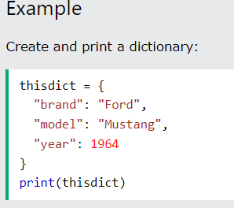
   * Dictionaries are used **to store data values in key:value pairs**.
4. **Python List**
5. **Sad**
6. **Asd**
7. **Asd**
8. **Asd**
9. **Asd**
10. **Asd**
11. **Asd**
12. **Asda**
13. **sd**